ELCT 201 – EE Laboratory 1

Digital Transformation of D&C Circuit Elements

Carson Murray

9 November 2022

Department of Electrical Engineering

University of South Carolina

Columbia, SC 29208

# Abstract

For this lab, we constructed a circuit with the same functionality as Project 6, but we utilized a microcontroller to implement it instead. The functionalities of the operational amplifier, the digital logic, as well as the potentiometers were translated into code that was run on the FRDM-KL25Z microcontroller. All the concepts discussed throughout this course are still present in this lab, but they are modified to support digital functionalities instead of analog functionalities. This project allowed the similarities between analog and digital devices to be apparent as well as their ability to work in combination with each other. Lastly, the propagation delay of the circuit is tested and compared to that of Project 6.

# Circuit Construction

The circuit construction for this project includes 3 main sections: user inputs, sensor inputs, and power output. The circuits complexity has decreased compared to Project 6 due to the micro-controller’s ability to synthesize the sensitivity calibration, and digital logic components into code. The circuit schematic for project 7 can be seen in Figure 1:

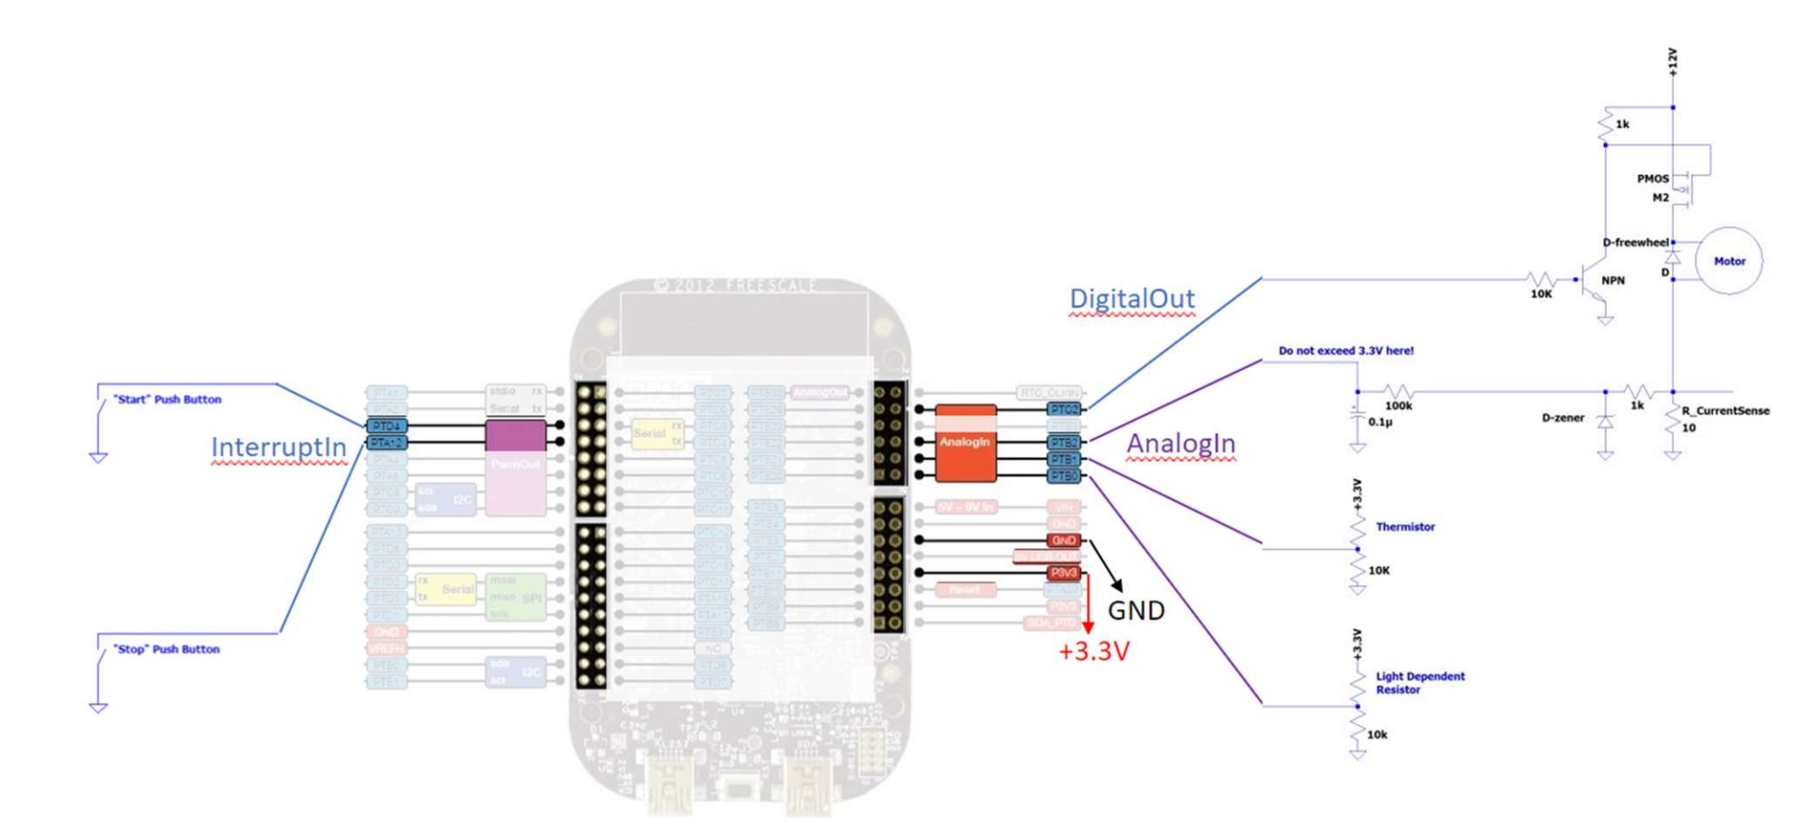

Figure : A microcontroller-based implementation of the motor control system introduced in Project 6.

## User inputs

The user inputs for this project consists of “Start” and “Stop” push button. The “Start” push button turns on the motor, whereas the “Stop” push button turns off the motor. These buttons allow the user to start or stop the motor without giving any inputs to any of the other sensors. Both buttons served as inputs to the microcontroller as the “Start” push button is connected to the PTD4 port and the “Stop” button is connected to the PTA12 port.

## Sensor Inputs

The sensors included in this circuit are a thermistor, light detecting resistor (LDR), and a current sensor. The thermistor turns the motor off when the temperature applied to it exceeds a threshold. Similarly, the current sensor can detect when a torque is applied and will shut off the motor when the current exceeds its threshold. On the other hand, the LDR will activate the motor when a light is shown on the sensor. All the thresholds for the sensors are defined within the code of the microcontroller. Each of the sensors are connected to input ports on the microcontroller, as the LDR, thermistor, and current sensor are connected to the PTB0, PTB1, and PTB2 ports respectively.

## Power Output

The power output subsystem allows the digital output from the microcontroller to power a motor. To achieve this, the digital output of the microcontroller (port PTC2) is connected to the base pin of the NPN transistor while its emitter is grounded, and the collector is connected to the P-channel MOSFET. The MOSFET acts as the main power supply to the motor, as 12 volts are supplied to it. A D-freewheel diode is connected to the output of the MOSFET to dissipate the current stored in the motor. It is important to note that the 12 volts supplied to the MOSFET are not connected to the voltage input of the microcontroller as this will damage it. Instead, 3.3 volts, should be connected to the P3V3 port, and grounded to either of the GND ports.

# Description of Software

As stated before, the sensitivity calibration and digital logic aspects of the circuit have been converted into code instead of analog components. This allows the user to customize the functionality of the circuit as well as the sensitivity of the sensors.

## Code initialization

At the beginning of the code, it is important to initialize the variables that will present within the code. Values for the biasing resistors for each sensor as well as their respective threshold values are initiated. Determining the values for the threshold level was completed by connecting the output voltage of each sensor as well as the input voltage to the oscilloscope. Applying stimulus to each sensor and looking at the oscilloscope reveals where the threshold needs to be set. The ports of the microcontroller are also defined and connected. Functions for the “Start” and “Stop” are defined to display whether the motor is started or stopped when a button is pressed as well as change the value of the Output variable to on or off.

## Sensitivity calibration

Within the code for this project there are many functions dedicated to the sensitivity calibration for each of the sensors present. Each sensor has a function to “Get” information from the sensor as well as a function to “Check” whether the information from the sensor has exceeded the threshold. For example, The LDR’s “Get” function first reads in the data from the sensor, then converts this value to a voltage. The LDR’s resistance value is then calculated using the voltage divider equation and returned. The “Check” function contains an if-statement that will start the motor when the LDR’s resistance value is less than or equal to its threshold. This allows the sensor to activate the motor when a light from a flashlight is shown upon it. The “Check” function utilizes the “Get’ function to obtain the LDR’s resistance value and compare it to the threshold. The concept for the “Get” and “Check” functions for each sensor are generally the same.

## Main method

The main method for this code drives all the functions developed for this microcontroller. First, the “Start” and “Stop” pushbuttons are connected to their respective functions within the code. Next, the red, green, and blue LEDs are initialized to be off, and then the blue LED is scheduled to blink once to show the program is running. Then, a while loop is implemented so that the sensors can be constantly checked. This is done by calling each of the sensor’s “Check” functions. After those functions are called, the LDR resistance value, temperature value, and motor current are displayed to the console. This while loop will run until the user decides to stop the program. The combination of the code initialization, sensitivity calibration functions and the main method, allows the microcontroller to utilize the user and sensor inputs and apply power to the motor.

# Investigation of Time Delay

In the previous project, we were required to measure the propagation delay between the input of a “set” condition and when the motor received power. The previous project consisted of many analog components within the digital logic causing the delay, but this project removes all these components and replaces them with code. I hypothesized that the time delay between the “set” condition and the moment the motor received power would be shorter due to digital components being inherently faster than analog components.

To test my hypothesis, the output of the “Start” pushbutton as well as the input to the digital output of the microcontroller were connected to Channel 1 and 2 of the oscilloscope. The oscilloscope was then set to record a single event so that the time delay between the two signals could be determined. To get an understanding of the delay that was present, 10 trials of the delay were taken. The oscilloscope screenshot representing the delay of the first trial can be seen in Figure 2:

Figure : Oscilloscope screenshot representing the time delay between the “Start” button being pressed, to the moment the motor receives power.

The oscilloscope screenshot of the delay appears to look similar in appearance, but the time delay appears to be significantly more than that of the analog circuit (~152 ns). The results of the experiment can be seen in Table 1 and Figure 3 .



Table : Results of the Time Delay experiment

Figure : Scatter Plot of the Time Delay experiment

The data collected for this experiment rejects my hypothesis and instead suggests that the delay between the “Start” pushbutton is pressed and the moment the motor is powered is greater in the digital version of the circuit than the analog version of the circuit. The wait time that is present in the while loop might be a factor in the amount of time delay present. Therefore, decreasing the wait time might result in a decrease in time delay.

# Conclusions

The transition from analog to digital components in this project allows the user to see the differences between the two. Implementing a microcontroller allowed the circuit to be less complex and easier to understand but requires an understanding of the code running. The use of digital components can be very useful in a variety of projects, especially if the user is accustomed and familiar with coding. Lastly, it was interesting to see that there was an increase in propagation delay within the digital version of this circuit.